Exercise 5: Triggers

Scenario 1: Automatically update the last modified date when a customer's record is updated.
o Question: Write a trigger UpdateCustomerLastModified that updates the LastModified column of the Customers table to the current date whenever a customer's record is updated.

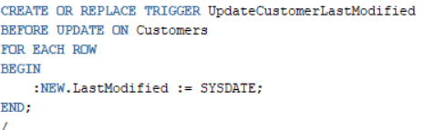
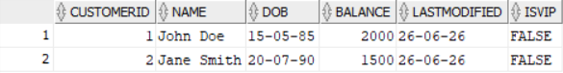

Scenario 2: Maintain an audit log for all transactions.
o Question: Write a trigger LogTransaction that inserts a record into an AuditLog table whenever a transaction is inserted into the Transactions table.
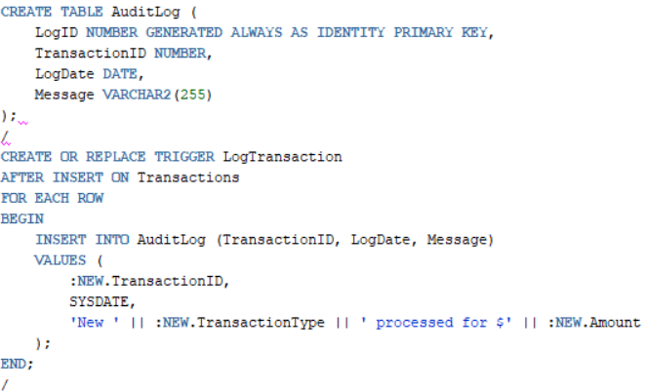
Scenario 3: Enforce business rules on deposits and withdrawals.
o Question: Write a trigger CheckTransactionRules that ensures withdrawals do not exceed the balance and deposits are positive before inserting a record into the Transactions table.
